**Full Stack Development with MERN**

**ShopSmart: Your Digital Grocery Store (Grocery Shop)**

**1. Introduction**

This project is a MERN Stack application designed to provide a seamless and modern online grocery shopping experience. It allows customers to browse products and make purchases, while providing administrators with tools to manage the store.

**1.1 Purpose** The primary purpose is to move beyond the traditional, manual process of grocery shopping by providing a convenient, real-time, and user-friendly online platform.

**2. Ideation Phase**

**2.1 Problem Statement** Traditional grocery shopping can be time-consuming and inconvenient, involving travel, long queues, and fixed store hours. This creates frustration for busy customers.

**2.2 Empathy Map Canvas**

* **Customers:** Are often frustrated with the time wasted in queues and travel. They need a quick and efficient way to buy daily necessities and want access to a wide variety of products from home.
* **Store Admins:** Need a streamlined and simple system to manage product inventory, update prices, and track what customers are buying.

**2.3 Brainstorming**

* Real-time product Browse
* User account registration and login
* Shopping cart functionality
* Admin panel for product management (Create, Read, Update, Delete)
* Role-based access (Customer vs. Admin)

**3. Requirement Analysis**

**3.1 Customer Journey Map** Registration -> Login -> Browse Products / Search for Products -> Add Item to Cart -> Manage Cart -> Proceed to Checkout -> Manage Profile/Orders

**3.2 Solution Requirements**

* User Registration & Authentication
* Product Management (by Admin)
* Shopping Cart System
* A clean, responsive User Interface

**3.3 Technology Stack**

* **Frontend:** React
* **Backend:** Node.js / Express
* **Database:** MongoDB

**4. Project Design**

**4.1 Problem Solution Fit** Provides a digital, web-based solution to the physical limitations and inconveniences of traditional grocery shopping.

**4.2 Proposed Solution** A role-based web application for customers and an administrator. Customers can browse and buy products, while the admin manages the store's inventory.

**4.3 Solution Architecture** Frontend (Client Side) -> Backend API -> MongoDB (Database)

**5. Project Planning & Scheduling**

| Week | Task |
| --- | --- |
| 1 | Requirements & Planning |
| 2 | UI/UX Design & Prototyping |
| 3 | Frontend Development |
| 4 | Backend Development & API |
| 5 | Integration & Testing |
| 6 | Final Submission & Review |

Export to Sheets

**6. Functional and Performance Testing**

* **Performance Testing Tools:** Postman (for API response time), Browser Dev Tools (for frontend load time).
* **API Response Time:** Optimized to be less than 500ms for most queries.
* **Database Query Time:** Optimized through proper indexing on the MongoDB collections.

**7. Results**

The project resulted in a fully functional e-commerce web application with the following key screens:

* 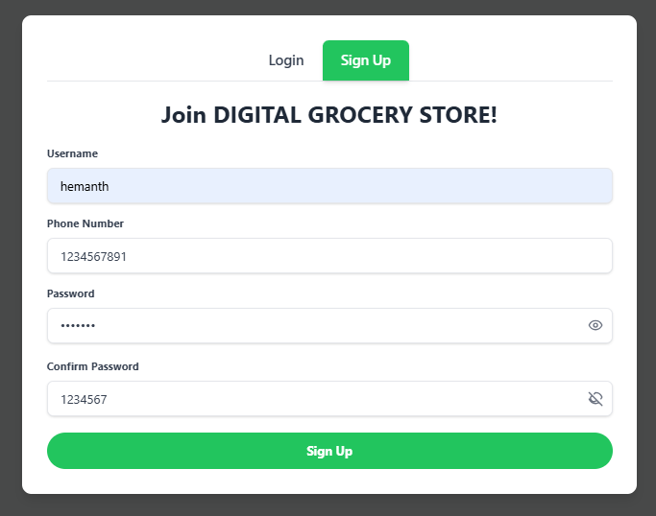**User Sign Up & Login**
* 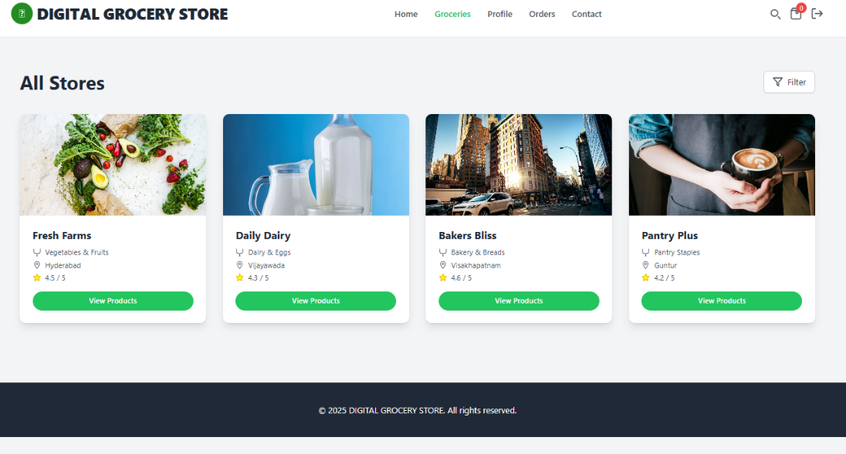**Home Page & Grocery Stores**
* 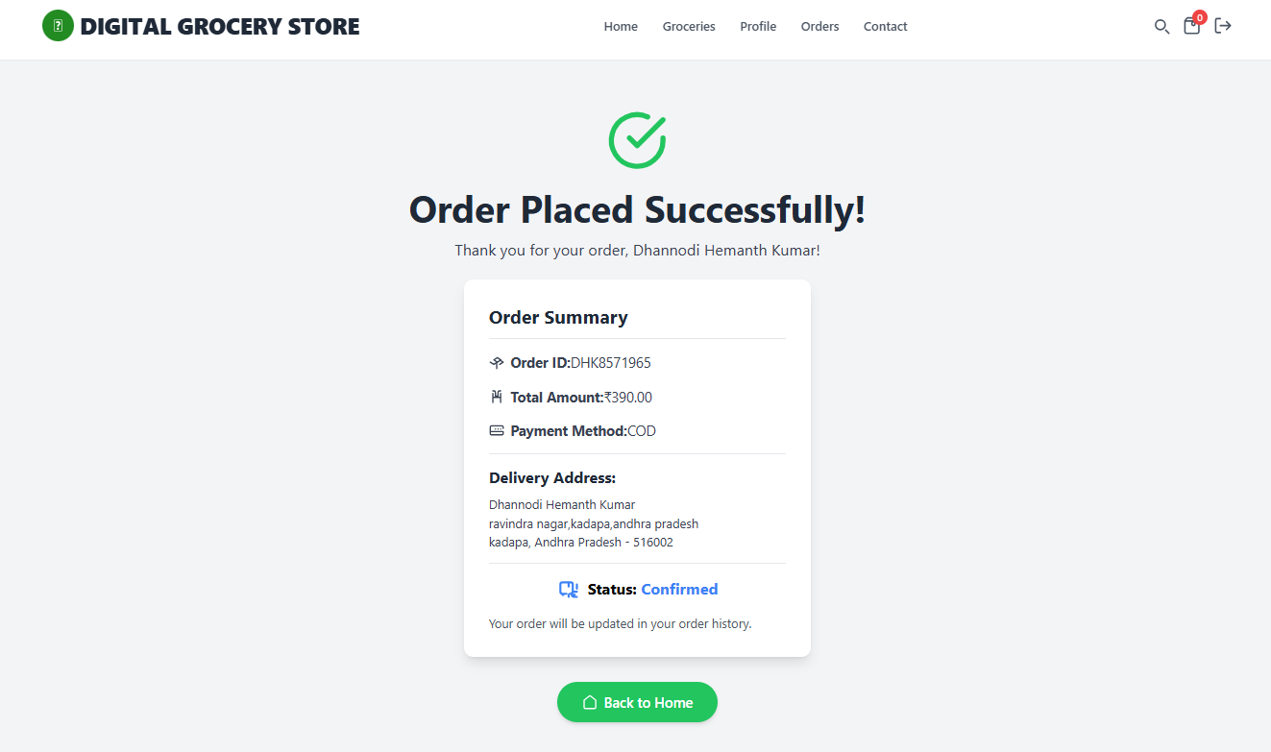Order Details & Order Status
* **Order History**

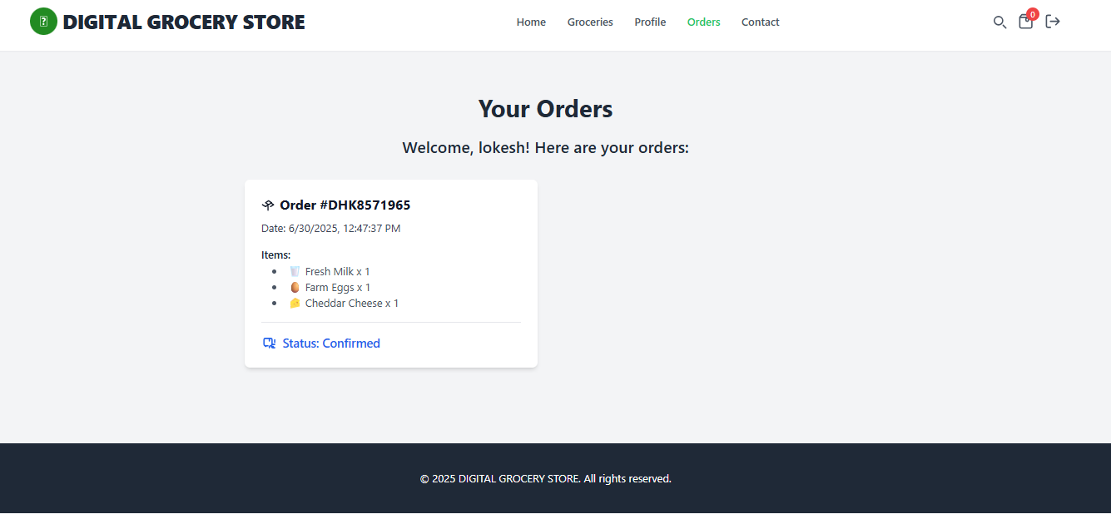

**8. Advantages & Disadvantages**

**Advantages:**

* **Convenience:** Customers can shop 24/7 from anywhere.
* **Scalable:** The application is built to handle a growing number of products and users.
* **Simple UI:** The user interface is clean and easy to navigate.
* **Centralized Management:** Easy for the admin to manage all products from one dashboard.

**Disadvantages:**

* **No Payment Gateway:** Does not include a real-world payment processing system.
* **Basic UI Design:** The UI is functional but could be enhanced with more advanced design elements.
* **No Physical Inspection:** Customers cannot physically see or touch products before buying.

**9. Conclusion**

The Digital Grocery Store project successfully provides an efficient and effective online shopping system. It connects customers with products in a seamless digital environment and provides a solid foundation for a real-world e-commerce business.

**10. Future Scope**

* **Payment Gateway Integration:** Integrate Stripe or PayPal for real online transactions.
* **JWT Authentication:** Enhance security with JSON Web Token (JWT) for users and admins.
* **Cloud Deployment:** Deploy the application on a cloud service like AWS, Heroku, or Vercel.
* **Mobile App:** Develop a native mobile application for Android and iOS.
* **SMS/Email Notifications:** Implement automatic notifications for order confirmation and shipping updates.